Task 4- REST - Country Web Service

1. Project Structure

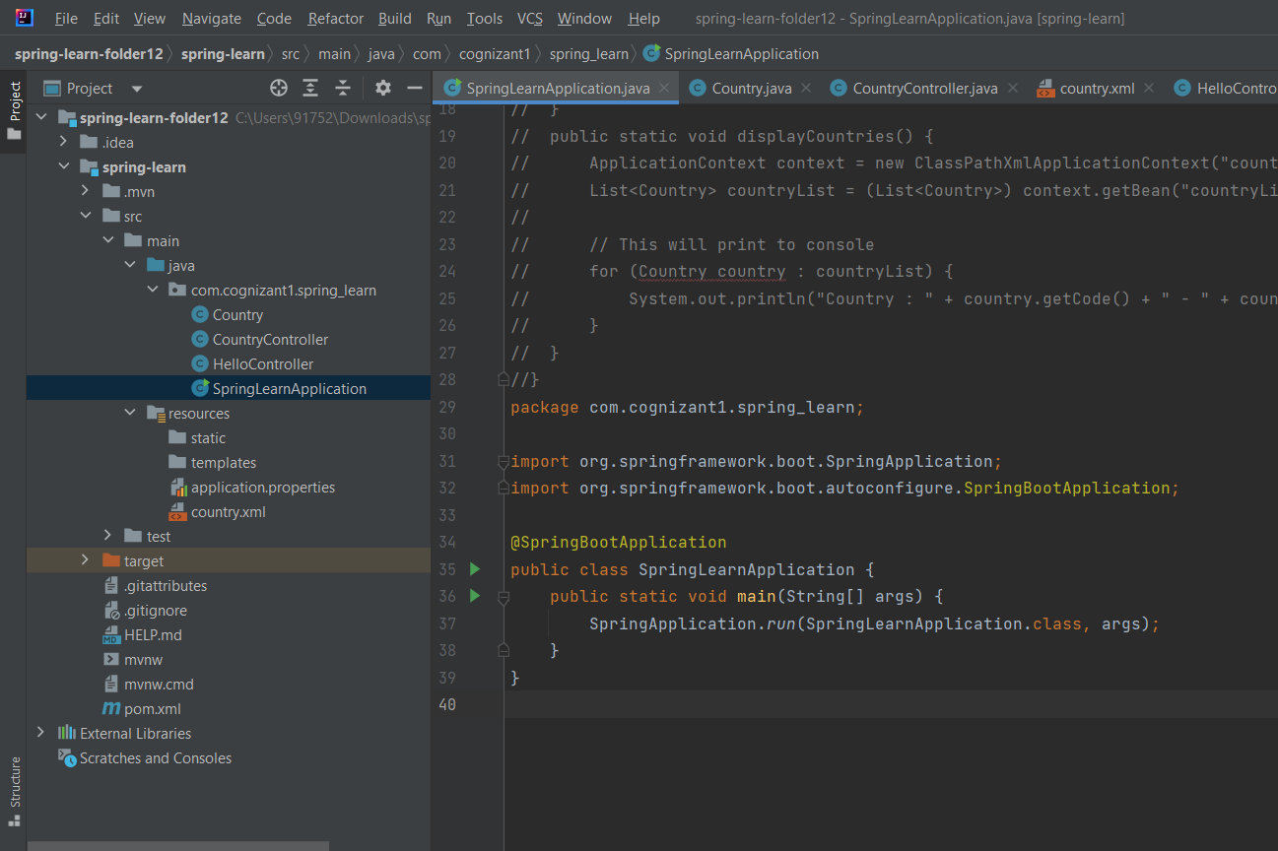

1. Country.java
2. package com.cognizant1.spring_learn;  
     
   import org.slf4j.Logger;  
   import org.slf4j.LoggerFactory;  
   import org.springframework.context.ApplicationContext;  
   import org.springframework.context.support.ClassPathXmlApplicationContext;  
     
   import java.util.List;  
     
   public class Country {  
    private static final Logger *LOGGER* = LoggerFactory.*getLogger*(Country.class);  
     
    private String code;  
    private String name;  
     
    public Country() {  
    *LOGGER*.debug("Inside Country Constructor.");  
    }  
     
    public String getCode() {  
    *LOGGER*.debug("Inside getCode");  
    return code;  
    }  
     
    public void setCode(String code) {  
    *LOGGER*.debug("Inside setCode");  
    this.code = code;  
    }  
     
    public String getName() {  
    *LOGGER*.debug("Inside getName");  
    return name;  
    }  
     
    public void setName(String name) {  
    *LOGGER*.debug("Inside setName");  
    this.name = name;  
    }  
     
    @Override  
    public String toString() {  
    return "Country{" +  
    "code='" + code + '\'' +  
    ", name='" + name + '\'' +  
    '}';  
    }  
     
     
     
    public static void displayCountries() {  
    ApplicationContext context = new ClassPathXmlApplicationContext("country.xml");  
    List<Country> countryList = (List<Country>) context.getBean("countryList");  
    for (Country country : countryList) {  
    *LOGGER*.debug("Country : {}", country);  
    }  
    }  
   }

3-CountryController.java

package com.cognizant1.spring_learn;  
  
import org.slf4j.Logger;  
import org.slf4j.LoggerFactory;  
import org.springframework.context.ApplicationContext;  
import org.springframework.context.support.ClassPathXmlApplicationContext;  
import org.springframework.web.bind.annotation.RequestMapping;  
import org.springframework.web.bind.annotation.RestController;  
  
@RestController  
public class CountryController {  
  
 private static final Logger *LOGGER* = LoggerFactory.*getLogger*(CountryController.class);  
  
 @RequestMapping("/country")  
 public Country getCountryIndia() {  
 *LOGGER*.info("START: getCountryIndia()");  
  
 ApplicationContext context = new ClassPathXmlApplicationContext("country.xml");  
 Country country = (Country) context.getBean("country");  
  
 *LOGGER*.info("END: getCountryIndia()");  
 return country;  
 }  
}

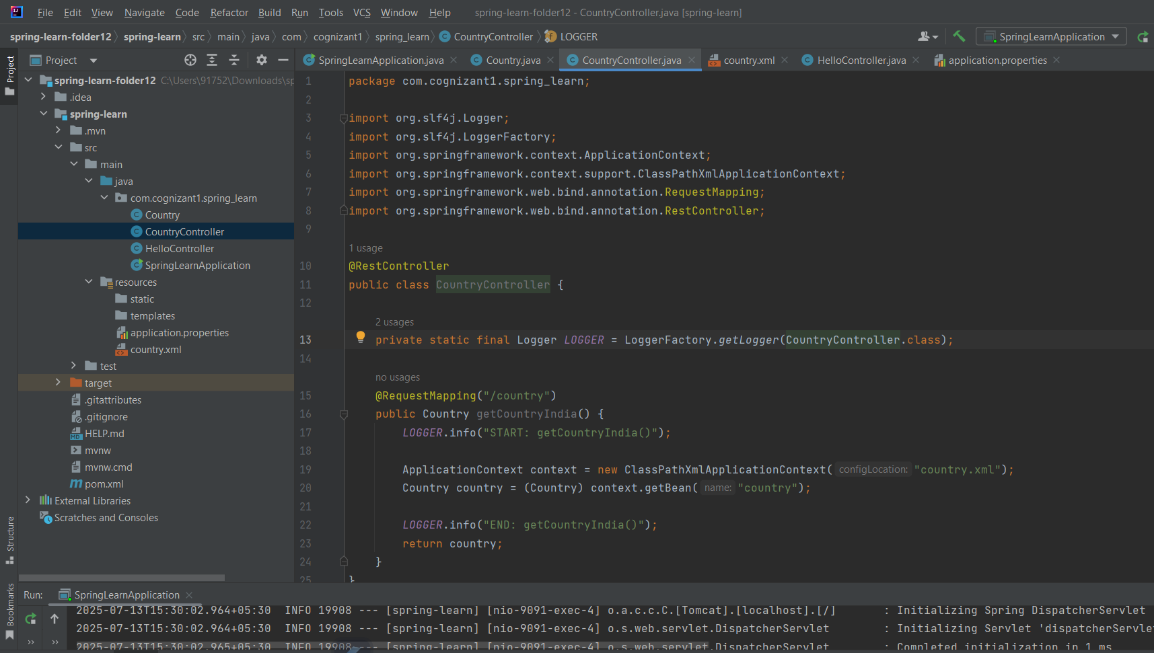

1. Output

